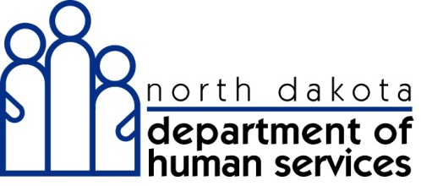

Provider Enrollment
Application Toolkit

North Dakota MMIS Web Portal
March 2013

Table of Contents
Introduction 3
North Dakota MMIS Web Portal 4
Features 4
Establishing secure web access and customized functionality during enrollment 4
System Requirements 4-5
Before Getting Started……………………………………………………………………………….6-7
Information to Gather Before Completing an Application 8
Provider Identifier Numbers 8
Identifying Information 8
Electronic Transaction Submissions 8
Legal Notifications 8
Electronic Funds Transfer (EFT) 8
Affiliations 9
Individual Providers 9
Group Providers 9
Additional Service Locations 10
Ownership and Exclusion/Sanction Information 11-12
Electronic Transaction Submissions 13
North Dakota MMIS Web Portal - Direct Data Entry 13
Vendor Software 13
Billing Agent/Clearinghouse 13-14
Registering for Web Access: Assigning an Organization Administrator 15-16
Tips for Completing an Electronic Application 17
Tips for Submitting an Electronic Application… 18
What to Expect after Submitting an Enrollment Application 19
While your application is pending 19
Approval 19
Tracking Application Status 20
Important Contact Information 21

Introduction

The N.D. Department of Human Services is about to transition from its legacy Medicaid Management Information System (MMIS) to a new web-based application. The new system is called the North Dakota MMIS Web Portal.

This transition will be a two phase process:

Phase One - Provider enrollment

Phase Two - Will allow providers to directly enter claims or upload batch transactions and will also offer real-time access to member eligibility, claims status, remittance advice, payment status and claims history. Additional information on Phase Two implementation will be provided at a later date.

The first phase of this transition includes enrollment of all active providers. This is required for all providers who plan to continue participation in the North Dakota Medicaid program.

Enrollment is necessary to collect additional data elements required by the new MMIS and to ensure N.D. Medicaid provider records are up to date and in compliance with current state and federal regulations. The enrollment process introduces providers to new system features and benefits and enables them to establish their preferred account settings for the new claims processing environment.

The enrollment includes:
- new enrollment application and review process
- assignment of new Provider IDs to all approved providers

The purpose of the Provider Enrollment Toolkit is to assist providers in completing the enrollment application.

North Dakota MMIS Web Portal

Features
The North Dakota MMIS Web Portal is a web-based claim management solution for administering N.D. Medicaid and other health care programs. Users will be able to access the system through a secure, user-friendly website 24 hours a day, 7 days a week via the Internet.

Online features and benefits of the new MMIS will include:

Phase One
- Online provider enrollment

Phase Two
- Claim submission with real-time edits
- Claim adjudication status
- Reusable claim “templates” customized for providers
- Claim correction and resubmission option
- Online help, provider billing manuals, reference materials, forms, and training materials
- Updates and information via a secure Provider Message Center
- Secure downloadable Remittance Advice, documents, and forms
- Member eligibility verification
- Service authorization requests and responses
- Inquiry, correspondence, and support
- Electronic Funds Transfer payment capability
- Self-service user access to the MMIS

Establishing secure Web access and customized functionality during enrollment
Through the enrollment application, you will have the ability to establish and customize the following features:
- Identify preference for how to receive your remittance advice
- Establish Electronic Funds Transfer for direct deposit of claims payments
- Electronic claims submission
- Set up the capability to manage employee access to secure features of the web-based application

System Requirements
The North Dakota MMIS Web Portal is supported using the following browsers:
- Internet Explorer versions 7.0 and higher
- Firefox version 3.6 and higher

The latest version of the Adobe Acrobat reader plug-in is required to view PDF documents. You can download Adobe from the North Dakota MMIS Web Portal under the documentation tab or when you download the enrollment package. You will be prompted if your browser does not have the Adobe Acrobat reader plug-in.

Before Getting Started

All providers will complete either an Individual or Group enrollment application. To determine which application and forms are required, follow the guidelines below.

Do you use a Social Security Number (SSN) or do you use an Employer Identification Number (EIN) to report income?
- Providers who use a SSN to file taxes will need to complete an Individual Enrollment Application.
- Providers who use an EIN to file taxes will need to complete a Group Enrollment Application.

Do you have multiple provider types?
- If so, each provider type needs to be listed on the application. Please see the section on how to add multiple provider types.

Do you practice at more than one service location using the same Tax ID and provider type?
- If so, providers will complete the Additional Service Location form for each service location. When completing the electronic enrollment application, the Additional Service Location Form can be completed as part of the initial electronic application. If the enrollment application is completed using a paper application, providers will need to complete a separate Additional Service Location application for each service location.

Does each service location have different licenses, certifications, or mailing and billing addresses?
- If so, this can be specified by location on the Additional Service Location form.

Do you have affiliations with providers or groups that bill on your behalf or that you bill for?
- If so, affiliates must be listed on the application for each service location.

Do you use Vendor Software to submit or receive X12N electronic transactions?
- If so, applicants will indicate that Vendor Software is utilized on the application. Providers who use Vendor Software are considered their own Trading Partner.

Do you utilize a Billing Agent or Clearinghouse?
- If so, providers will indicate if a Billing Agent or Clearinghouse is utilized on the application.
- The billing agent/clearinghouse will be required to enroll through the North Dakota MMIS Web Portal as a trading partner.

Does your group practice have tax-exempt status?
- If so, applicants will need to indicate non-profit status on the Group Enrollment Application and submit a copy of an IRS-issued exemption.

Once Phase Two is complete, do you intend to have claims payment deposited directly into your financial account?
- If so, applicants will select the Electronic Funds Transfer (EFT) option in the enrollment application.

Information to Gather Before Completing an Application

Prior to beginning the enrollment application, gather the following as applicable:

Provider Identifier Numbers
- Social Security Number (SSN) or Employer ID Number (EIN)
- N.D. Medicaid ID Number(s): current or previous number for applicant
- N.D. Medicaid ID Number(s): existing or newly assigned for each affiliated group practice or individual provider
- National Provider Identification Number (NPI)
- Drug Enforcement Agency number (DEA), if applicable
- National Council for Prescription Drug Program Number: a unique national identifier for pharmacies, if applicable
- Medicare Numbers: group Medicare numbers, individual Medicare numbers
- Provider Licensure/Certification and specialty information
- Taxonomy Code: national specialty codes used to indicate provider specialty

Identifying Information
- Street address and contact information for all service locations, billing, and mailing information
- Contact Names: individuals who are authorized to communicate verbally with the Department of Human Services
- Organizational Administrator: the person who will manage security for users in your organization
- Ownership: information for all owners or subcontractors who have more than a 5% ownership (Name, Date of Birth, SSN, Effective Date of Ownership)
- Name, Date of Birth, and SSN on all managing/directing employees, which means a general manager, business manager, administrator, director, or other individual who exercises operational or managerial control over or who directly or indirectly conducts the day-to-day operation of an institution, organization, or agency.

Electronic Transaction Submissions
- Vendor Software: software vendor name, version number, and protocol
- Billing Agent/Clearinghouse name, contact person, street address, and phone #

Legal Notifications
- Exclusion/Sanction official documentation for any imposed or pending occurrence due to a violation of federal program regulations

Electronic Funds Transfer (EFT)
- Bank information for direct deposit of claim payments

Affiliations

It is important to complete the group affiliations section of the application if individual providers perform services on behalf of a group. If the affiliation section is not completed, claims for services performed by the individual provider will be paid to the individual provider instead of the group provider.

Affiliations are not valid unless both parties associate each other within the MMIS system.

For individual providers, the affiliation is to the group providers or practices for which the provider performs services.

For group providers, the affiliation is to the individual providers who perform services on behalf of the group.

You will need the following information to complete the group affiliation section of the application:

Individual Providers

- Name of Group Practice - The legal name of all active N.D. Medicaid group practices on whose behalf you perform services.
- N.D. Medicaid Provider Number - The current or new N.D. Medicaid provider number for the group provider.
- Effective Date of Affiliation - The date the affiliation with the group practice began.

Group Providers

- Name of Individual Provider - The legal name of each individual provider who performs services on behalf of the group.
- N.D. Medicaid Provider Number - The current or new N.D. Medicaid provider number for the individual provider.
- Effective Date of Affiliation - The date the affiliation with the individual provider began.

Additional Service Locations

Enrolling applicants must provide details on the service location where they practice. Often, a provider may perform services as the same provider type in more than one service location. All additional service locations should be listed in the enrollment application.

The first service address entered on the application is considered the provider’s primary location.

Additional service locations must share the same information with the primary location including:
- Tax ID
- Provider type
- Ownership information
- Electronic claims submission information

Other details pertaining to additional service locations can be the same or different than the primary locations including:
- License and certification information
- Mailing/billing information
- Electronic Funds Transfer information
- Method of receiving remittance advices
- Provider affiliations
- Organizational administrator for Web access (this can be the same person, but each location needs to have a unique user ID and password)

Applicants with more than one service location must complete an Additional Service Location Form for each distinct location.

The electronic application includes the option to add additional service location details as one of the last steps prior to submitting the application for the primary location.

Applicants using paper will need to complete a paper copy of the Additional Service Location Form for each distinct location.

Ownership and Exclusion/Sanction Information

Authority
Title 42 Part 455 Subpart B of the Code of Federal Regulations implements sections 1124, 1126, 1902(a)(38), 1903(i)(2), and 1903(n) of the Social Security Act. Specifically, 42 CFR 455.104 requires the following.
§ 455.104 Disclosure by providers and fiscal agents: Information on ownership and control.
(a) Information that must be disclosed. The Medicaid agency must require each disclosing entity to disclose the following information in accordance with paragraph (b) of this section:
(1) The name and address of each person with an ownership or control interest in the disclosing entity or in any subcontractor in which the disclosing entity has direct or indirect ownership of 5 percent or more;
(2) Whether any of the persons named, in compliance with paragraph (a)(1) of this section, is related to another as spouse, parent, child, or sibling.
(3) The name of any other disclosing entity in which a person with an ownership or control interest in the disclosing entity also has an ownership or control interest. This requirement applies to the extent that the disclosing entity can obtain this information by requesting it in writing from the person. The disclosing entity must—
(i) Keep copies of all these requests and the responses to them;
(ii) Make them available to the Secretary or the Medicaid agency upon request; and
(iii) Advise the Medicaid agency when there is no response to a request.
(b) Time and manner of disclosure. (1) Any disclosing entity that is subject to periodic survey and certification of its compliance with Medicaid standards must supply the information specified in paragraph (a) of this section to the State survey agency at the time it is surveyed. The survey agency must promptly furnish the information to the Secretary and the Medicaid agency.
(2) Any disclosing entity that is not subject to periodic survey and certification and has not supplied the information specified in paragraph (a) of this section to the Secretary within the prior 12-month period, must submit the information to the Medicaid agency before entering into a contract or agreement to participate in the program. The Medicaid agency must promptly furnish the information to the Secretary.
(3) Updated information must be furnished to the Secretary or the State survey or Medicaid agency at intervals between recertification or contract renewals, within 35 days of a written request.
(c) Provider agreements and fiscal agent contracts. A Medicaid agency shall not approve a provider agreement or a contract with a fiscal agent, and must terminate an existing agreement or contract, if the provider or fiscal agent fails to disclose ownership or control information as required by this section.
(d) Denial of Federal financial participation (FFP). FFP is not available in payments made to a provider or fiscal agent that fails to disclose ownership or control information as required by this section.
In compliance with this regulation, applicants are responsible for completing all information requested on the enrollment application.
Tips for Group Providers
The number of owners entered on question #1 must be matched with an entry providing details, as requested on the application, for each owner.

Electronic Transaction Submissions

Providers may choose the option to submit or receive electronic transactions during Phase One, but the electronic transaction functionality will be available upon Phase Two implementation. It is strongly suggested that providers take advantage of this feature. Electronic transactions will reduce errors and turnaround time of claim processing.

There are three electronic transaction submission options to choose from on the application.

North Dakota MMIS Web Portal – Direct Data Entry
Claims can be entered directly into the North Dakota MMIS Web Portal. Submitting claims electronically is a great option for providers who currently submit paper claims.

The Web Portal will perform basic data checks before the claim is submitted for processing, reducing the number of denied claims and turnaround time of claims processing.

Additional benefits of the Web Portal direct claims submission include:
- Claim Adjudication - Instant availability of anticipated claim payment amount upon submission of a claim
- Claim Status Inquiry - Allows immediate access to view claims
- Payment Inquiry - Allows providers to check payment history and print Remittance Advices
- Claim Templates - Allows for the creation of a template to be used for commonly submitted claims

Vendor Software
A provider who uses Vendor Software to submit or receive transactions in X12N format is considered their own Trading Partner. A provider may elect this option as part of the electronic enrollment application.

Providers who are their own Trading Partner will:
- Receive two Application Tracking Numbers (ATN) at the completion of the electronic application: one provider ATN and one Trading Partner ATN
- Receive two welcome letters: one for the provider and one for Trading Partner
- Be contacted by a Department of Human Services representative regarding testing of transactions once Phase Two is implemented. Testing will need to be successful before Trading Partners will be able to submit and receive electronic transactions

Billing Agent/Clearinghouse

Providers who utilize the services of a Billing Agent or Clearinghouse to submit or receive electronic transactions will indicate the contact name, address, and phone information for the Billing Agent/Clearinghouse.

Providers should encourage their Billing Agent or Clearinghouse to complete the Trading Partner Enrollment application as soon as possible.

Registering for Web Access: Assigning an Organization Administrator

Providers are required to register for Web access as part of the enrollment application. This allows providers to take advantage of all the features in the new system.

Providers must identify an individual employee as the Organization Administrator (Org Admin). The Org Admin is in charge of maintaining the User IDs and login accounts to access the North Dakota MMIS Web Portal.

An Org Admin has the ability to reset Automatic Voice Response telephone system PINs and Web Portal passwords, and to add and maintain users for their organization. This maintenance includes updating a user's account profile, resetting a user's password, unlocking a locked User ID, and deactivating User IDs if needed.

Controlling access to the North Dakota MMIS Web Portal and the Automatic Voice Response telephone system is critical for complying with confidentiality requirements, including HIPAA. The security functions controlled by the Org Admin ensure that only authorized users have access to the MMIS Web Portal guaranteeing that unauthorized users cannot access the information.

Applicants with more than one service location must register for Web access for each service location. Each service location will have its own unique user ID and password to access the MMIS system.

It is recommended that applicants identify a different Org Admin for each service location.

The following fields must be completed:
- Organization name
- Organization description
- User ID: This is a unique ID your Org Admin will use.
  - The User ID should consist of the first initial of the first name, followed by the entire last name (no spaces or punctuation). If this User ID is already in use, the system will suggest alternate IDs to use.
Note: User ID can contain between 6-16 alphanumeric characters, no spaces, no special characters, and is case sensitive.
- Contact name and phone number of your Org Admin

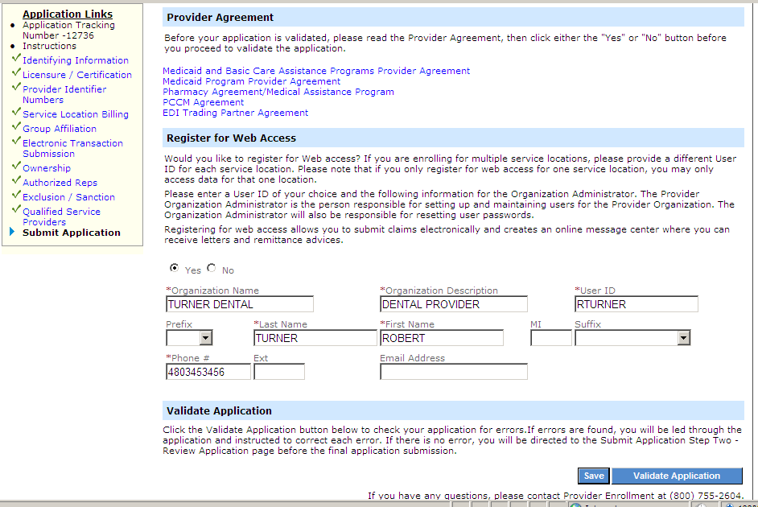
This example shows how to complete the enrollment application to become an Organization Administrator.

Tips for Completing an Electronic Application

Help Options
The new MMIS has built-in help features that are always available for reference. There are three types of online help:

- Global Help
- Panel Help
- Help Pods

Global Help is available by clicking the Help link in the top right portion of any MMIS Web page. You can select a topic or use the search feature to look for a specific word or phrase within the help files of the Web Portal.

Panel Help is a link available for each panel within the enrollment application. Panel help is specific to the information contained in the current panel.

Help Pods can be found on the left side of the provider enrollment pages. It contains formatting information and tips on completing this particular section of the application.

Application Links Pod
The Application Links Pod can be found on the left side of the provider enrollment pages. This pod contains links that navigate directly to the selected section of the application.

- A green check indicates which application sections have been completed.
- A red X indicates which application sections include errors.

Note: The forward and back buttons on the browser should not be used when using the North Dakota MMIS Web Portal. To navigate forward, use the continue button or the Application Links Pod. To move back use the Application Links Pod.

Application Tracking Number
Each application will be assigned an Application Tracking Number (ATN). This number will appear in red text at the top of the page after a successful page level save. This number can also be located in the Application Links Pod on the left.

Important: Be sure to write your ATN number down in case you need to recall or refer to the application.

Save
Panel Save will temporarily save the newly entered information to the panel.

Page Level Saves are completed using the Blue Save Button at the bottom of the Web page. Clicking this button saves newly entered information to the database and immediately validates the data entered.

Important: It is highly recommended that that you save each page of the application.

Tips for Submitting an Electronic Application

After submitting your application, you will be sent to a “submit complete” Web page. This is the only time you will see this Web page.

Several important things should be done before you leave this page.

- Print a copy of the “submit complete” Web page, which must be used as a cover page when sending in all of your required documents. This Web page contains the Application Tracking Number (ATN) that is used to link the required documentation to the electronic application.
- One copy MUST accompany the required documentation submitted.

- Print the enrollment application for your files using the print application button.

- Prepare required documents
- The document requirements checklist identifies additional documents that should be submitted with the application (i.e. copies of licenses and certifications).
- Be prompt in mailing required documentation. Supporting documents must be received within 30 days of the application submit date or a new application may need to be completed.

Mail supporting documents to:
N.D. Department of Human Services
Provider Enrollment
600 E. Boulevard Avenue, Dept. 325
Bismarck, ND 58505-0250
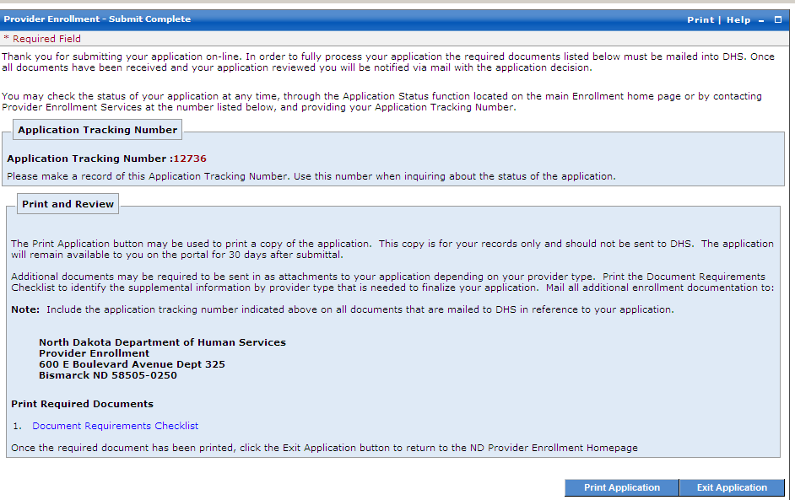
What to Expect after Submitting an Enrollment Application
This image shows the “Submit Complete” page. You must print this page and mail it to the N.D. Department of Human Services along with other needed documents listed in 3 above.

While your application is pending:

- The enrollment process should be completed within four to six weeks after the Department receives a complete application and supporting documentation. Any omission or missing information will cause a delay in this time period.

- If you submitted your application electronically you may check the status of your application using the North Dakota MMIS Web Portal. You will need your Application Tracking Number (ATN). Reference the “Application Status” handout for a description of each application status.

- If you submitted your application on paper you may call Provider Enrollment (1-800-755-2604) to check the status of your application.

Approval:

- When an enrollment application is approved, the provider will receive a welcome letter that includes a new N.D. Medicaid Provider ID number and the User ID that the applicant chose for the North Dakota MMIS Web Portal for each service location.

- A system generated password for the North Dakota MMIS Web Portal and PIN for the Automated Voice Response system (AVR) will be received in a separate letter.
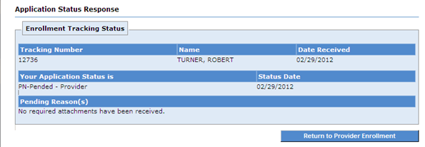

You will receive this image of information when you check the status of your application from the Web Portal.

Tracking Application Status

Processing an enrollment application requires several steps. The application status codes listed below will help you track the status of your application.

In Process - The mailed documentation was received by Provider Enrollment and the application is under review.

Pended Provider - The submitted Web enrollment application was received by the Department of Human Services Provider Enrollment, but all of the required documentation has not been received. If partial documentation is received, a letter is generated to the provider detailing which documents are missing.

Pended State - The enrollment application has completed the first step of the review process and is referred to provider enrollment for review.

Approved - The enrollment application is approved.
- Upon approval of an enrollment application, providers will receive a welcome letter that includes a User ID for logging into the North Dakota MMIS Web Portal. Providers will also receive a second letter containing their Automated Voice Response telephone system PIN and North Dakota MMIS Web Portal password.

Cancelled - The enrollment application is cancelled. To become a N.D. Medicaid provider, a new enrollment application must be submitted.
- At the time of the cancellation, the provider will receive a letter via mail with the reason for the cancellation.
- For example an application may be cancelled because documents did not arrive within the 30 day time limit for submission.

Denied - The enrollment application is denied.
- At the time of the denial, the provider will receive a letter via mail with the reason for the denial.

In addition the following status applies to Trading Partners only:

Application Complete - Application has been submitted and all required documents have been received.

Important Contact Information

Contact N.D. Department of Human Services Provider Enrollment regarding:

- New Provider Enrollment
- Provider Enrollment Changes
- Application Status
- Questions about the North Dakota MMIS Web Portal

Address:
North Dakota Department of Human Services
Provider Enrollment
600 E. Boulevard Avenue, Dept. 325
Bismarck, ND 58505-0250

Phone: (800) 755-2604
ND Relay TTY: (800) 366-6888
Email: dhsmmis@nd.gov

For more information and frequent updates, go to www.nd.gov/dhs/info/mmis.html

The Web page contains:
- Training and materials to support provider enrollment
- Updated manuals and computer-based training videos
- Frequently asked questions
- Project updates

