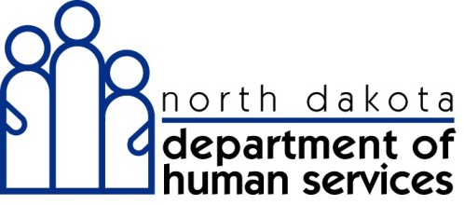

Trading Partner Enrollment
Application Toolkit

North Dakota MMIS Web Portal
April 2013

Table of Contents
Contents
What is a Trading Partner? 3
System Requirements 4
Registering for Web Access: Assigning an Organization Administrator 4
Tips for Completing an Electronic Application 5
Help Options 5
Application Links Pod 6
Application Tracking Number 6
Save 6
Tips for Submitting an Electronic Trading Partner Application 7
What to Expect after Submitting an Enrollment Application 8
While your application is pending: 8
Approval: 8
Tracking Application Status 9
Important Contact Information 10

This document is intended for trading partners only. If you are a provider, please refer to the Provider Enrollment Toolkit.

What is a Trading Partner?
A Trading Partner is any entity that submits or receives transactions using X12N standard format.
If you are a Trading Partner you will need to complete a Trading Partner application.
There are six different classifications to identify what type of trading partner is being enrolled:
- Billing Agent – A third party that is authorized by the provider to bill on their behalf
- Provider/Self – An individual or organization that uses their own software or a third party software to submit their own medical claims
- Switch Vendor – A clearinghouse for Pharmacies
- Clearing House - A clearinghouse is a private or public company that provides connectivity and often serves as a “middleman” between physicians and billing entities, payers and other health care partners for transmission and translation of claims information (primarily electronic) into the specific format required by payers.
- Other Payer – A third party payer that adjudicates claims
- Carrier – Carriers are health insurance companies that maintain third party resource/billing relationships. Third parties include, but are not limited to, private health insurance, worker’s compensation and Medicare. Carriers are limited to submitting and receiving the 271 (TPL Coverage Response) and 270 (TPL Coverage Inquiry)

Before you get started with the Trading Partner application you will need to gather the following:
- Affiliated carrier information; Carrier ID, date of affiliation, and transaction types (if applicant is a Carrier, Switch Vendor, or Clearing House)
- Affiliated provider information; North Dakota Medicaid number and date of affiliation (for everyone except Carriers)
- Trading Partner contact person(s)
- Determine who the Organization Administrator will be. (For more information on the Organization Administrator please see “Assigning an Organization Administrator / Web Access” of the Trading Partner Enrollment Toolkit).
Note: Once the Trading Partner application is approved, the Trading Partner will be contacted by a North Dakota Department of Human Services (DHS) representative regarding testing of transactions. Testing will need to be successful before Trading Partners will be able to submit and receive electronic transactions.

System Requirements
The ND MMIS Web Portal is supported using the following browsers:
- Internet Explorer versions 7.0 or higher
- Firefox version 3.6 or higher

The latest version of the Adobe Acrobat reader is required to view PDF documents. Adobe is used for viewing applications, additional documents and forms. You can download Adobe from the ND MMIS Web Portal under the Documentation Tab or when you download the enrollment package. You will be prompted if your browser does not have Adobe Acrobat reader.

Registering for Web Access: Assigning an Organization Administrator
Trading Partners are required to register for web access as part of the enrollment application. Web access allows trading partners to take advantage of all the features in the new system.

Trading Partners must identify an individual employee as the Organization Administrator (Org Admin). The Org Admin is in charge of maintaining the User IDs and login accounts to access the ND MMIS Web Portal. An Org Admin has the ability to reset Automated Voice Response (AVR) PINs and Web Portal passwords, and to add and maintain users for their organization. This functionality will only be available once the system is fully operational. This maintenance includes updating a user's account profile, resetting a user's password, unlocking a locked User ID, and deactivating User IDs if needed.

Controlling access to the ND MMIS Web Portal and the AVR telephone system is critical for maintaining HIPAA compliance. The security functions controlled by the Org Admin ensure that only authorized users have access to the MMIS therefore guaranteeing unauthorized users cannot access the information.

The following fields must be completed:
- Organization Name
- Organization Description
- User ID: This is a unique ID your Org Admin will use. The User ID should consist of the first initial of the first name entered, followed immediately by the entire last name entered (no spaces or punctuation). If this User ID is already in use, the system will suggest alternate IDs to use.
Note: User ID can contain between 6-16 alphanumeric characters, no spaces, no special characters and is case sensitive.
- Contact Name and phone #: This is the name of your Org Admin

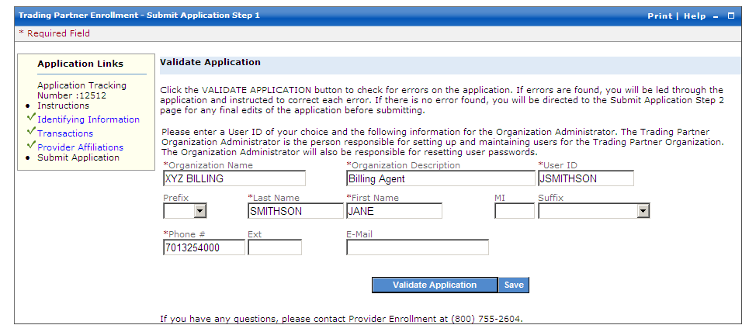
This example shows how to complete the enrollment application to become an Organization Administrator.

Tips for Completing an Electronic Application

Help Options
The new ND MMIS Web Portal has built in Help options. This on-line help is always available for reference. There are three types of online help:
- Global Help
- Panel Help
- Help Pods

Global Help is available by clicking the Help link in the top right portion of any web page. From here you can select a topic or use the search feature to look for a specific word or phrase within the help files for all of the ND MMIS Web Portal.
Panel Help is a link available for each panel within the enrollment application. Panel level help is specific to the information contained in the current panel.
Help Pods can be found on the left side of the provider enrollment pages. The Help Pod contains formatting information and tips about completing this particular section of the application.

Application Links Pod
The Application Links pod can be found on the left side of the provider enrollment pages. This pod contains links that navigate directly to the selected section of the application.
- A green check displays in the Application Links pod to indicate which web pages have been completed.
- A red X displays in the Application Links pod to indicate which web pages include errors or omissions.

Note: The forward and back buttons on the browser should not be used when using the North Dakota MMIS Web Portal. To navigate forward, use the Continue Button or the Application Links Pod. To move back use the Application Links Pod.

Application Tracking Number
Each application will be assigned an Application Tracking Number (ATN); this number will be shown in red text at the top of the page after a successful page level save. This number can also be located in the Application Links pod on the left. It is important to document this number for future reference.

Save
Panel Save will temporarily save the newly entered information to the panel.
Page Level Saves are completed using the Blue Save Button at the bottom of the web page. Clicking this button saves newly entered information to the database and immediately validates the data entered.
Important: It is highly recommended that that you save each page of the application.

Tips for Submitting an Electronic Trading Partner Application
After submitting your application you will be sent to the “Submit Complete” webpage. This is the only time you will see this web page. Several important things should be done before you leave this page:
- This web page contains the Application Tracking Number (ATN) that is used to link any required documentation to the electronic application.

- Print the enrollment application for your files using the Print Application button.
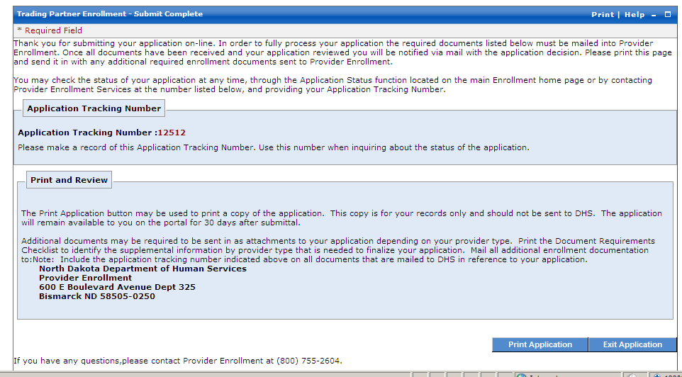
This image shows the “Submit Complete” page. You must print this page and mail it to the N.D. Department of Human Services along with other needed documents.
Mail supporting documents to:
N.D. Department of Human Services
Provider Enrollment
600 E. Boulevard Avenue, Dept. 325
Bismarck, ND 58505-0250

What to Expect after Submitting an Enrollment Application

While your application is pending:
- The enrollment process should be completed within four to six weeks after receipt of a complete application and supporting documentation. Any omission or missing information will cause a delay in this time period.

- If you submitted your application electronically you may check the status of your application using the ND MMIS Web Portal. You will need your Application Tracking Number (ATN). Reference the “Application Status” handout for a description of each of the statuses.

- You may contact Provider Enrollment to check the status of your application. A Provider Enrollment Specialist can be reached at (800) 755-2604 during business office hours from Monday to Friday 8 am – 5 pm.

Approval:

- When a Trading Partner’s enrollment application is approved the Trading Partner will receive a Welcome letter that includes a new Trading Partner ID number and a User ID for the ND MMIS Web Portal.

- A password for the North Dakota MMIS Web Portal and PIN for the Automated Voice Response system (AVR) will be received in a separate letter.

Tracking Application Status
You will receive this image of information when you check the status of your application from the Web Portal.
Processing an enrollment application requires several steps. The application status codes listed below will help you track the status of your application.
In Process – The mailed documentation was received by Provider Enrollment and the enrollment application is under review.

Pended – The submitted web enrollment application was received by Provider Enrollment but all of the required documentation has not been received. If partial documentation is received, a letter is generated to the provider detailing which documents are missing.

Application Complete – Application has been submitted and required documentation has been received.

Approved – The enrollment application is approved.
Upon approval of an enrollment application Trading Partners will receive a Welcome letter that includes a User ID for logging into the North Dakota MMIS Web Portal. Trading Partners will also receive a second letter containing their AVR PIN and Web Portal password.

Cancelled – The enrollment application is cancelled. To become a Trading Partner, a new enrollment application must be submitted.
At the time of the cancellation, the provider will receive a letter via mail with the reason for the cancellation.
For example an application may be cancelled because documents did not arrive within the 30 day time limit for submission.

Denied – The enrollment application is denied.
At the time of the denial, the provider will receive a letter via mail with the reason for the denial.

Important Contact Information
Contact DHS Provider Enrollment regarding:

- New Provider Enrollment
- Provider Enrollment Changes
- Application Status
- Questions about the North Dakota MMIS Web Portal

Address:
North Dakota Department of Human Services
Provider Enrollment
600 E. Boulevard Avenue, Dept. 325
Bismarck, ND 58505-0250

Phone: (800) 755-2604
ND Relay TTY: (800) 366-6888
Email: dhsmmis@nd.gov

For more information and frequent updates, go to www.nd.gov/dhs/info/mmis.html

The Website contains:
- Training materials to support provider enrollment
- Updated manuals and Computer Based Trainings
- Frequently asked questions
- Schedule updates

The North Dakota website will be updated throughout enrollment, so check back often!

